Kona Orchid Society  E-Newsletter | March 2021 Vol. 1, Issue 1  Published by Kona Orchid Society, a non-profit organization  www.konaorchidsociety.org

Inside

This

Issue
PG. 2
The club and the future where are we going from here?

PG. 3
Show and Tell Orchids: Members share their orchids

PG. 4
Orchid Experience: The hobby during COVID

PG. 5
Orchid diseases: Viruses
“Educating our members and the public about the collection, culture and appreciation of orchids.” | A Message from our president  Welcome to our first E-newsletter!  As COVID has drastically changed how we are able to live our lives, and for all the negativity that has come from it, hopefully we can find some good. My hope is that by having to find new ways to connect, things like this publication can bring a spot of light in these troubling times.  Each publication will include a species spotlight, disease identification and treatment methods, a feature article, and a section for “Show and Tell Orchids”, for this section I will need your help as it will feature orchids grown by members. More about this later, for now enjoy our first issue.  --Whitney

Club happeningS

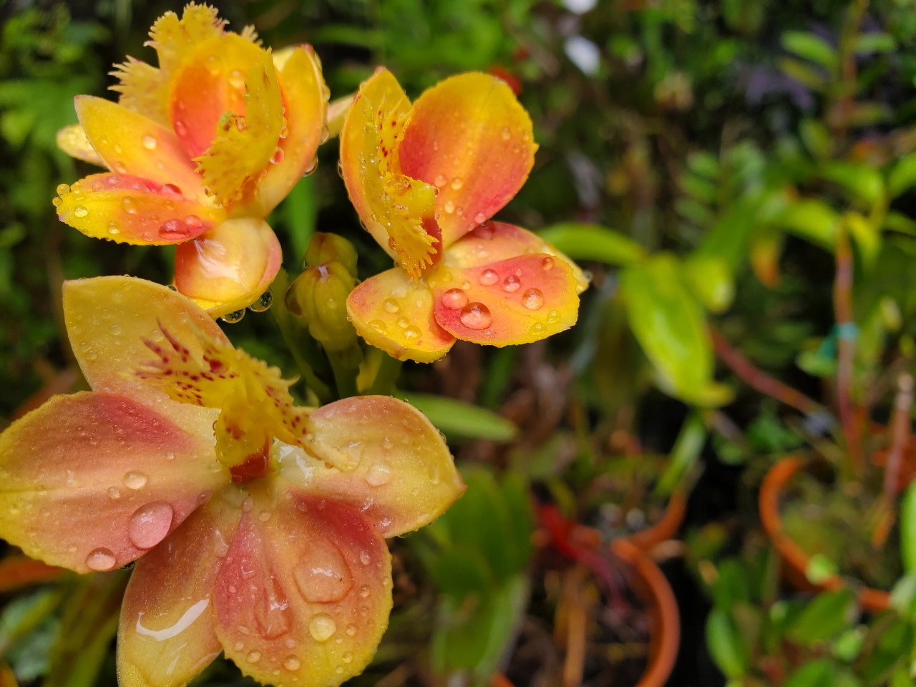

A big Thank you to Linda Baseman and Janice Beason for all of their years of service to the Board and the club.
Epidendrum hybrid, Whitney Steele

Welcome to our New Member
Stuart Clements

Ideas for the Year
- Garden Tour
- Nursery Bus Tour
- New Member Packets
- Change the food table at meetings to a “Plant Swape” table
We welcome any and all ideas for speaker topics and activities
March Board Meeting

New Officers and Board
President: Whitney Steele
V.P: Jan Ray
Secretary: Susan Elliott
Treasurer: Dennis Bensen

Returning Trustees:
Kathy Penwell
Brenda Kuessner

New Trustees:
Anita Kelleher, Ellie Lomax, and Geri Allison

No Dues for current members in 2021
Mother’s Day Sale for 2021 has been Canceled
Any alternative ideas would be welcome

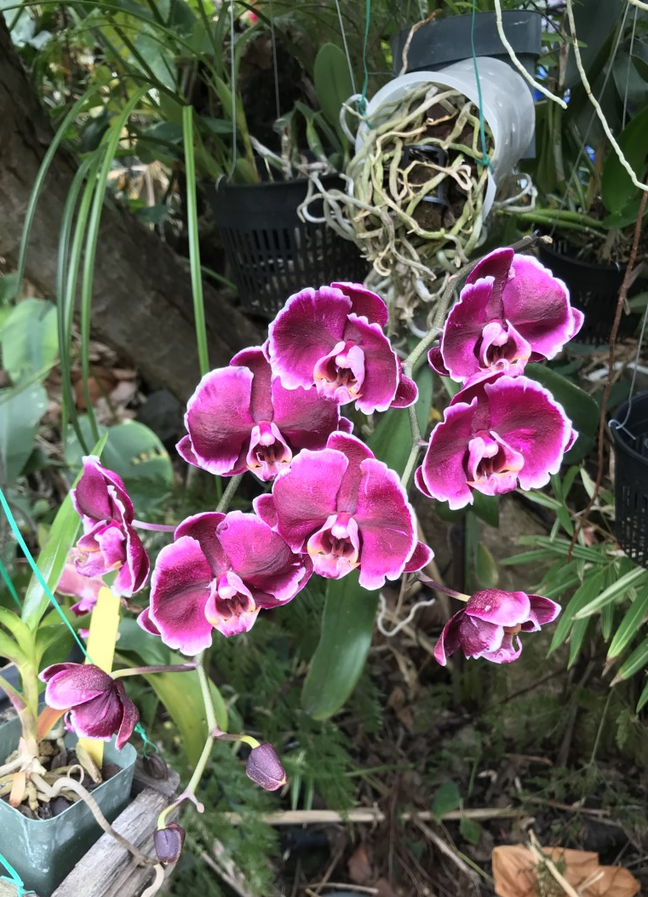
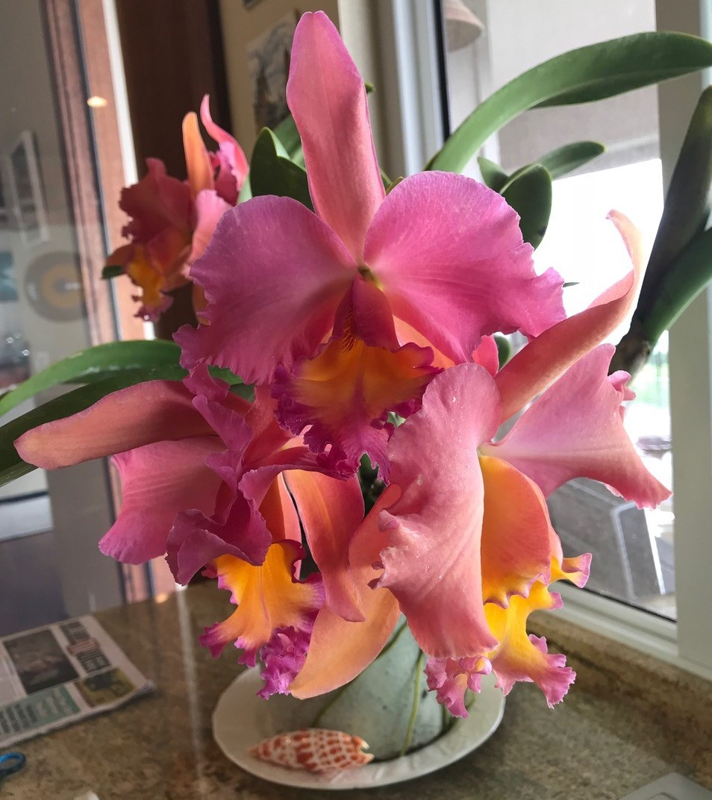
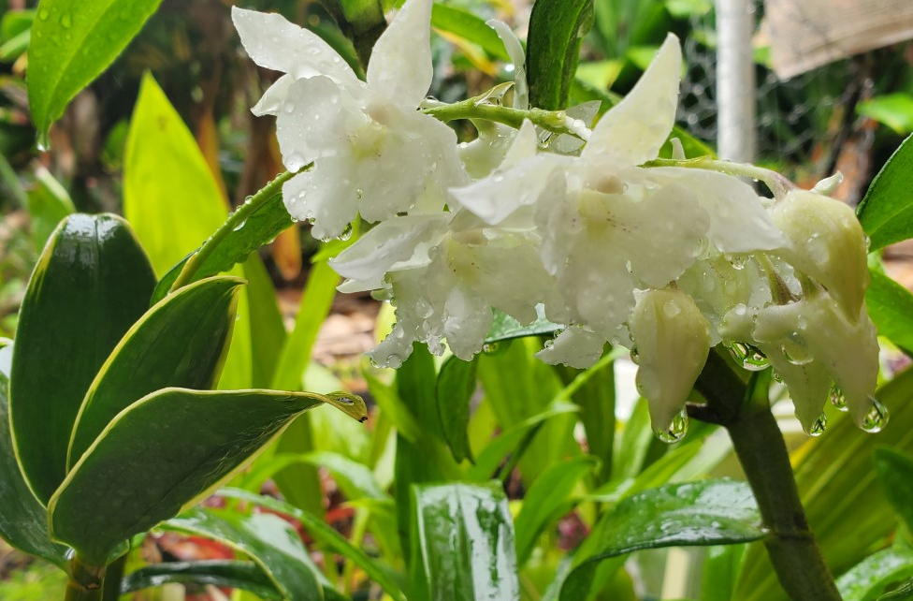
Member Plant Show and Tell
Den. Golden Nugget, Whitney Steele
Phalaenopsis hybrid, Kathy Penwell
Cattleya Born on the Bayou, Anita Kelleher
Cattleya ludemiana
This page will be for members to show off their blooming orchids.

Please email your phots of blooming plants to kos@konaorchidsociety.org to be included.

Also feel free to send phots of problem orchids so we can help.

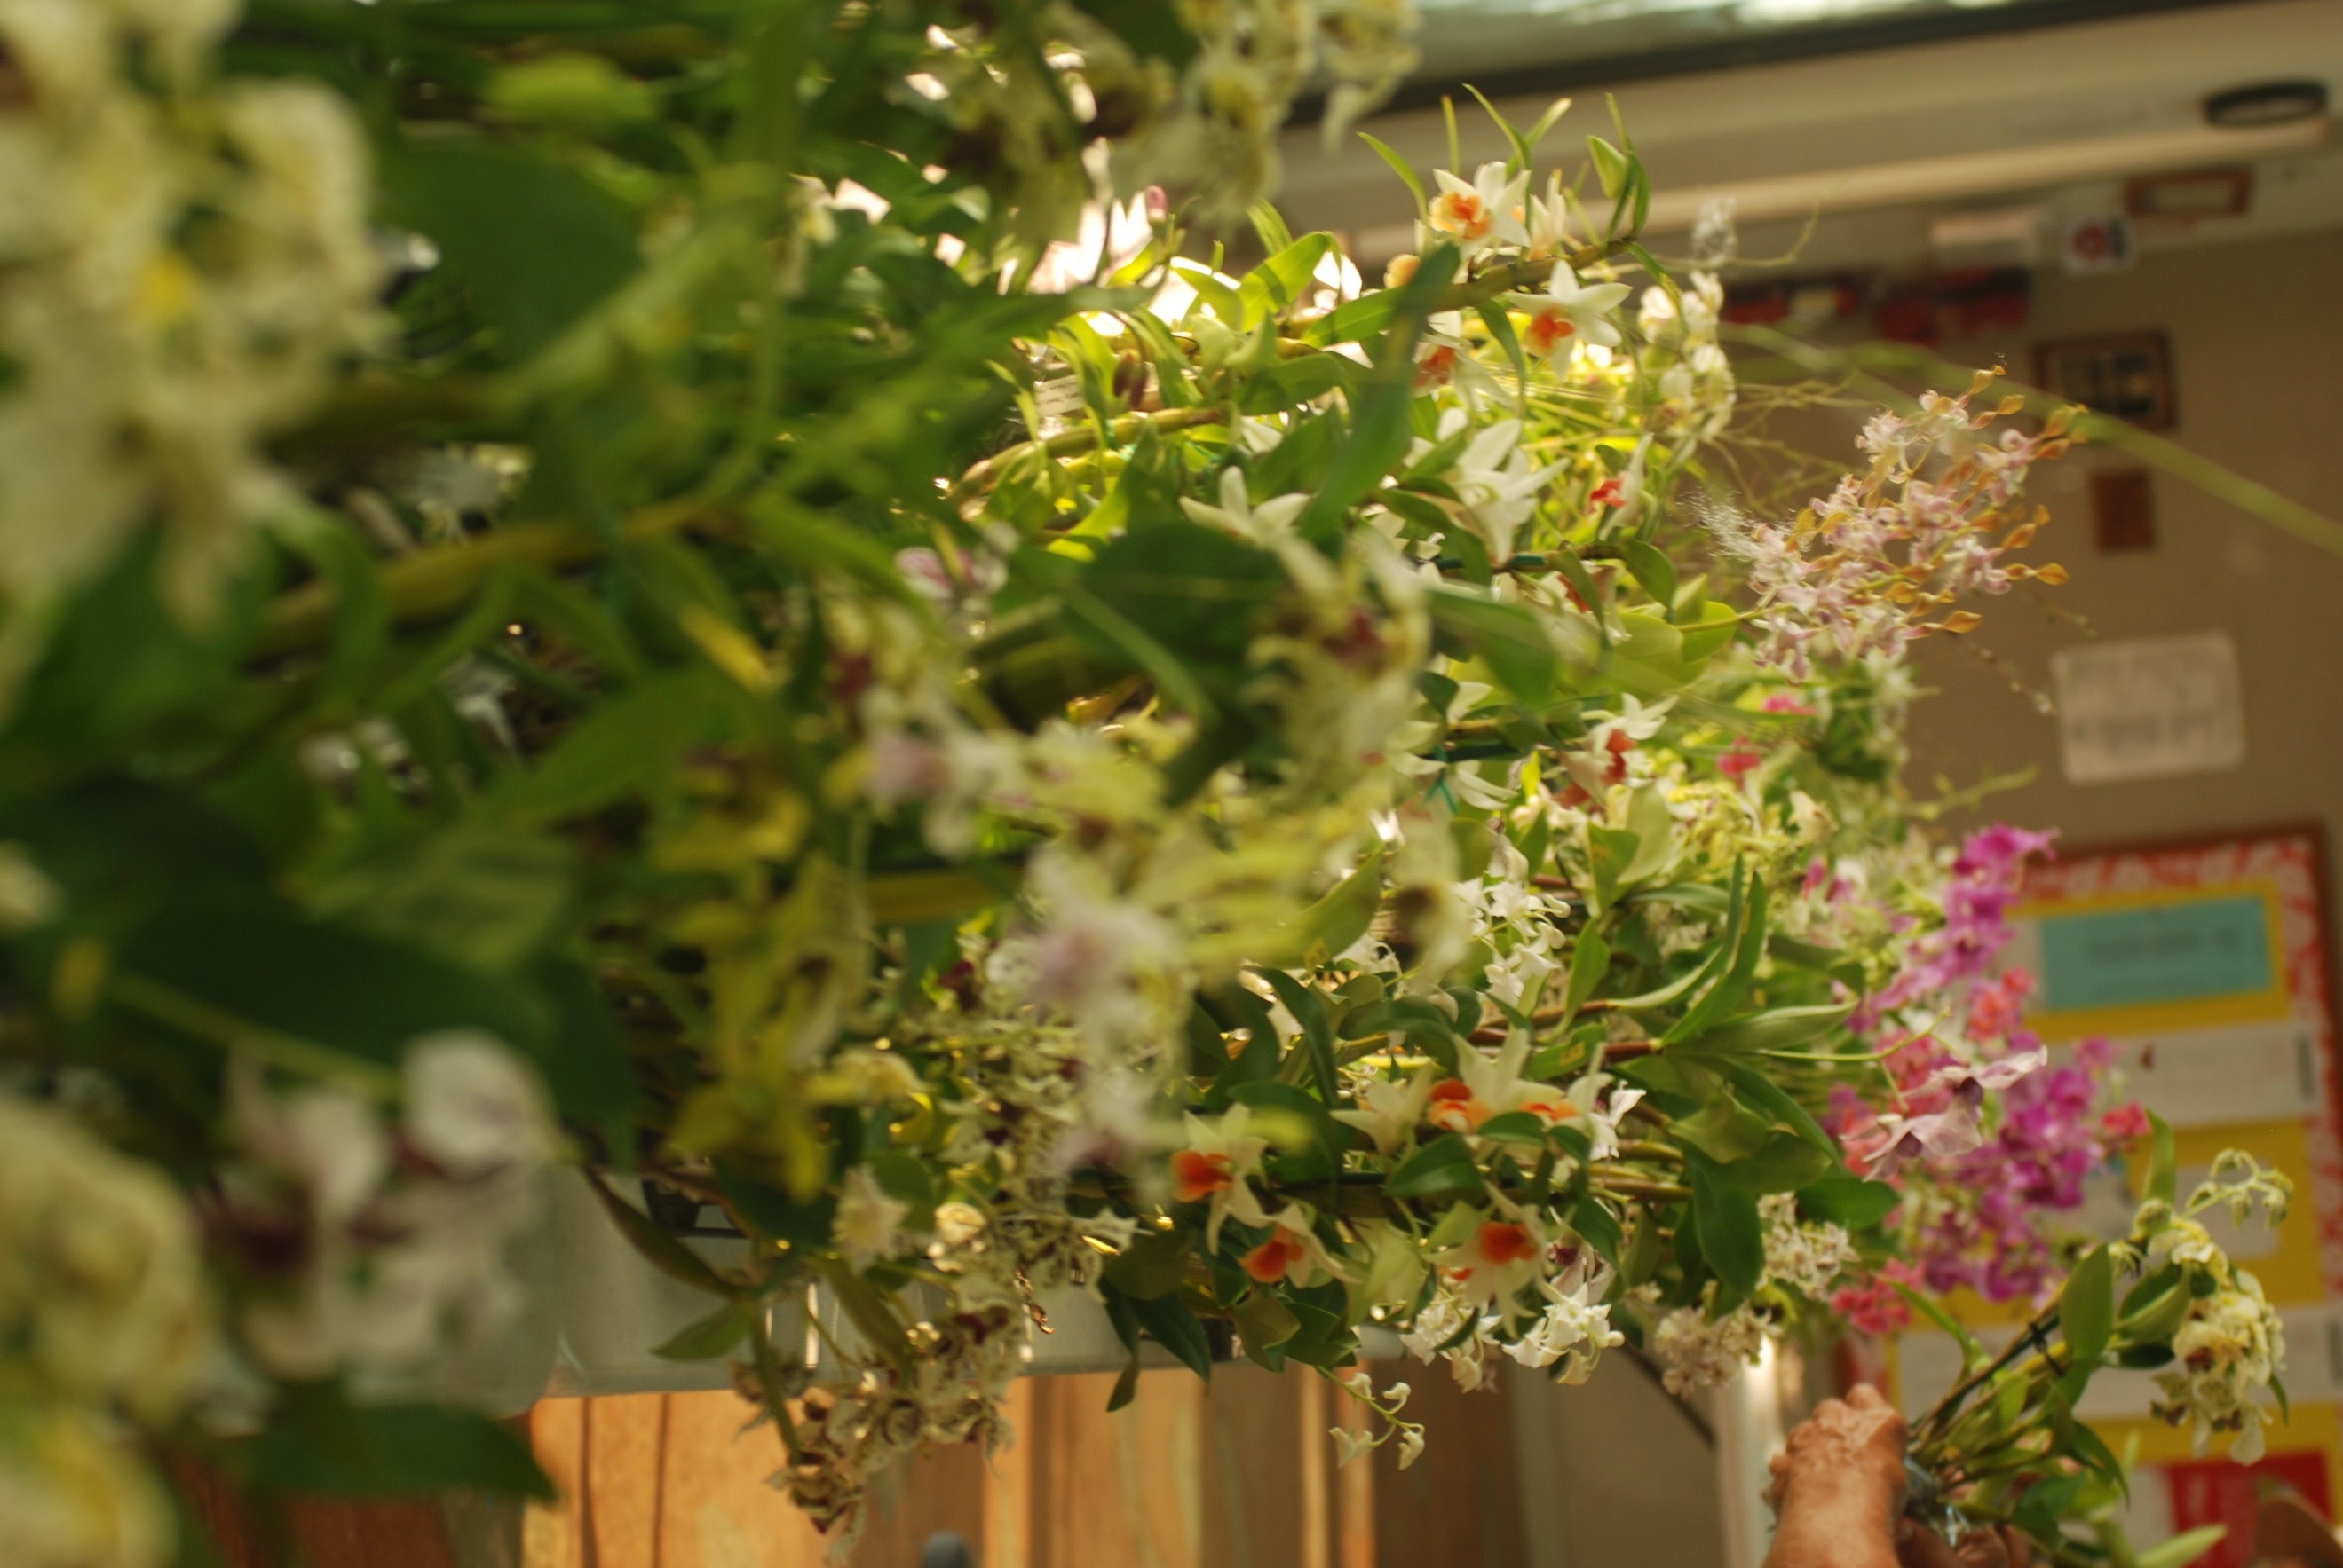
Orchid Experience: Orchids in the Time of COVID
Steps to Ordering Orchids Out of State

- Obtain state Import permit and pay fee
https://hdoa.hawaii.gov/pi/files/2012/12/pq-7_fillable.pdf

- With permit in hand you can now order! But only what is listed on the permit.

- You will also need a Certificate of Origin permit. This is offered by most growers for an additional fee.

- When the plants arrive, they will be inspected by the Department of Agriculture before being shipped to your address.

Article written by: Kathy Penwell
has covered. I got a permit to bring some into Hawaii. His main specialty are phalaenopsis species and he has many primary hybrids he has developed. He has been hybridizing for over 25 years, of many genera. The previous topics are available on You Tube.

Hilo had a Zoom presentation March 13 on the efforts of a college in Illinois to save one of the 3 endemic Hawaiian orchids that are near extinction. Dr. Zettler and his graduate students have grown enough plants that they have gone to Kauai and planted them into the swamp there. They discovered the mycorrhiza fungus needed to successfully germinate the seeds. Years ago, our society got a seed pod and Carmelas got it to germinate but without the right fungus they grew it for a while and then the flask began to die off. We visited it for a couple of years and slowly watched it decline. So, it is funny that a college in Illinois might end up saving our highly endangered orchid. There is no commercial value to them as they aren’t showy or even very pretty. It is Peristylus holochila.

Happy Growing! Kathy Penwell
Well, we have passed a year now, a year of missed meetings and orchid shows. But it hasn’t all been doom and gloom. I personally have traveled all over the world the past year and been to nurseries in S. Africa, Ecuador, Brazil, England and some US states mostly California and Florida all through the magic of Zoom. The Orchid Digest presented a Speakers Day with growers from around the world. I have been attending the Honolulu Orchid Society meetings via Zoom and they have even been able to do their raffle (lucky number) every month.

Hilo has been doing Zoom meetings since last April with some great speakers since they were able to show us their nurseries even though they were thousands of miles away. It is one thing having a speaker show us slides in person but even more interesting when he/she does a presentation and is then able to show us their greenhouses. A great bonus was that some of the bigger nurseries offered discounts to society members on a group order. Seeing the growing areas often gave me ideas that helped in my orchid growing adventure.

Another interesting presentation is a weekly live broadcast for an hour on Saturday mornings from Norman’s orchids in Montclair, S.Calif. Norman has been doing them since last April and covers a different topic every week. He shows examples of the topic he is covering they are live demonstrations. His sister does a pre-show usually on how to put together orchid arrangements or something similar. You can message them questions during the presentation and they will answer you on the spot. Norman closes with a show & tell of plants in bloom or orchids you can order that he

Orchid Disease: Viruses
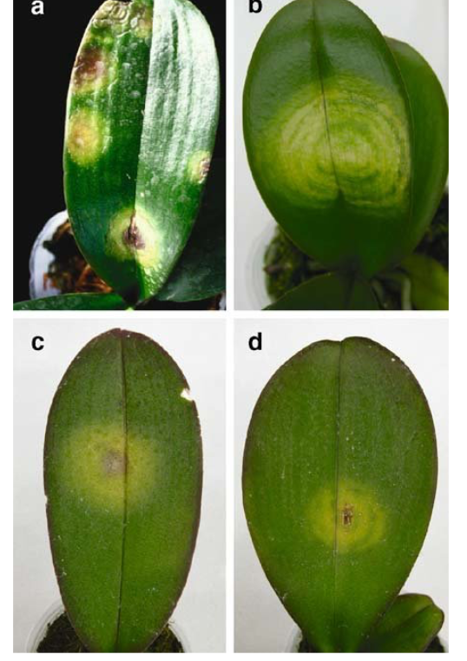
Article and photograph By: Phoenicia Zeller
With more than 30 viruses found and only the big 2 or 3 tested, one has to assume they are in every collection. I have a collection of virus photos that I’ve studied along the way. I hope that KOS members will take the time to go to some of the references I’ve listed and then follow their links. Get a good idea of what each looks like. When you see plants languishing, looking mottled, spotted, streaked, longitudinal lines in the leaves and sunken, flowers color breaking, think virus and segregate or toss. If it turns out to be bacteria, tossing is still a good idea. Fungus is the best outcome and can outgrow it or can be treated. I found the S Augustine Orchid Society newsletter and The Cymbidium Society of Victoria good starting places for research. By following the links they provided, I was able to find some of the newer virus data. The most common and tested viruses are easy to find. All the photos have similarities. It may not matter which one you have but that you have the potential ability to infect others. It’s the “wear a mask” of the orchid world. thinking. Keep your other plants safe.
I bet some of you will recognize the photos above. Of the new-to-me viruses, Capsicum chlorosis virus-Phalaenopsis (CaCV-Ph) is one I’ve seen and didn’t know the name of till now but I knew it was a virus. A rose by any other name etc. Do you want to put your time, money and psychological well-being into caring for plants that will look ugly, go downhill, or infect others? After the first heart wrenching toss of an ugly plant, it does get easier although tossing a full plug tray is stressful. I have a giant Den. Mousmee that has given me 39 spikes some years. It’s virused and I’ve kept it segregated for years. Now learning about thrips and mites, I might have to reconsider.
The word virus has been in the news and on our minds for the last year. I thought an update to viruses in orchids appropriate now. What we knew from before still holds. Virus is not curable by any method. Like Covid, the best thing is prevention, sanitation, and social distancing or spacing your plants. Orchids can be asymptomatic; we’ve heard that one in the news too. Virus in orchids is not a hoax. Some research shows virus can be transmitted by orchids rubbing each other. Other studies have shown that false spider mites carry Fleck virus and some thrips can carry other virus. Who hasn’t seen a thrip or two in their collections? I wipe out mites before I can tell if they are false or otherwise. Another problem is that virus may take years to show itself as in Cattleyas. Dendrobiums can show it much sooner. Sanitation takes on new meaning when some viruses can last for years on surfaces and “tobamoviral up to a decade under the right conditions” That everyone has virus seems to be the case. Some of us have more than others. “Viruses infected 50 percent of the orchids tested in Singapore's botanical gardens in a 1994 study, 25 percent of those grown in Hawaii in 1993, and 65 percent of the cut orchids from Thailand, the world's largest exporter, in 2005” Scientific American. These are old statistics.

